**Brief Mindfulness Intervention Manual:**

***Real-Time fMRI Neurofeedback***

2023

*Note*: The following procedures should be administered following assent/consent and the baseline clinical assessment

**Table of Contents**

|  |  |
| --- | --- |
| **Introductory Exercise:** Mindful Noticing | **3** |
| **Video:** Selective Attention | **5** |
| **Psychoeducation:** The Neuroscience of Mindfulness | **7** |
| **Intervention:** Noting Practice | **12** |
| **Scanner Instructions** | **15** |
| **Appendix** | **20** |

**Introductory Exercise: Mindful Noting**

**Estimated Duration:** 5 to 10 minutes

**Materials Needed:**

* Triangle

**Instructions:**

Begin the session by encouraging the participant to take a moment to stop, listen, and breathe… asking, what is here in this moment.

*Before we get started today, let’s take a moment to pause, listen to the sounds around us, feel our breaths, and explore what is here, in this moment.*

*Listen to what is around you… sounds outside the room… then inside the room… maybe to sounds your own body is making… just be present, pay attention to what sounds are here…*

Pause for ten to twenty seconds.

*Then really pay attention to the breath… bring curiosity… where does the breath* go *in the body? Focus on breathing in… and breathing out…*

*Just focus on the breath… breathing in… and breathing out…*

Pause.

Let the participant know you will next be ringing the triangle.

*In a moment, I will ring this triangle. You can close your eyes if you feel comfortable or just softly gaze in front of you without focusing on anything in particular. Listen to this chime. See if you can hear the subtle changes in its volume and intensity, see whether you can hear the exact moment the sound ends for you, see when it leaves your ears.*

**Discussion:**

Guide the participant in a conversation about their experience during the triangle exercise. Encourage them to consider how the experience might have affected their mood state.

*How was that experience for you? What did you notice?*

*How are you feeling at this current moment?*

*Did you notice any change during or after this practice?*

**Video: Selective Attention**

**Estimated Duration:** 5-7 minutes

**Materials Needed:**

* Video playing device cued to “[***The Monkey Business Illusion***](https://youtu.be/IGQmdoK_ZfY)*”*

**Instructions:**

Open the “**Mindfulness Checklist”** and “**Psychoeducational Files**” folder. Open and pause “**The Monkey Business Illusion**” video.

Ask the participant if they have heard of or participated in the “Invisible Gorilla Test.”

If yes, discuss what they learned from the experience.

Determine whether the participant watched the original Gorilla Test video, in which the only novel detail is the entrance of the person in the gorilla suit. If so, **continue** with the instructions below.

If they have seen the full video (with multiple changing details), **skip** to the discussion of selective attention vs. mindful awareness.

If no, explain that they do not need any prior knowledge to participate in the next segment of the session.

*I’m going to start this video in a minute. What I’d like you to do is simply count the number of times the ball is passed between players wearing white shirts.*

*Any questions?*

Play the “**The Monkey Business Illusion**.”

*So, how many times did the ball pass between people?* (Note: The correct answer is 16.)

*Did you notice anything unusual in the video?*

Possible correct responses:

Person in gorilla suit?

One person wearing black walks away?

Curtain changes from red to yellow?

If the participant correctly observed each detail, **skip** **to** the discussion of selective attention vs. mindful awareness. If any were omitted by the participant, identify those missed, then replay the video to show each of them.

Explain selective attention vs. mindful awareness.

*This video demonstrates the way that we can focus our attention and how shifting our attentional focus can change our experiences, like what we notice. First, you watched only for the ball and may have missed some things. Then, when I pointed out that certain parts of the video changed and asked you to notice them, you were able to do that right away!*

*As you just experienced, when we purposefully direct our attention to a specific goal, we can reduce distractions from the world around us. We may often feel like we don’t have control of what grabs our attention, but you can see that by focusing on something specific, we are able to attend more carefully to the tasks required of our consciousness. Next, we’ll talk about how and why this happens – as we discuss the neuroscience of mindfulness.*

**Psychoeducation: The Neuroscience of Mindfulness**

**Estimated Duration:** 15-20 minutes

**Introduction to Lesson**:

*Imagine you understood how the mind works, enough to enhance its potential with a brain training exercise. Well, the exercise is mindfulness, and now I’ll tell you a bit about the current neuroscience research on how the brain works and how you can have the power to change it with mindfulness.*

**Materials Needed:**

* iPad linked to [BrainFacts.org](https://www.brainfacts.org/3D-Brain#intro=false&focus=Brain-limbic_system)

**Lesson Content:**

**How Our Mind Works**

This next section of the session will review the neuroscience of mindfulness and highlight key concepts.

**Instructions:**

*“*Consciousness*” is the state of wakefulness, awareness, or alertness – it is where we function when we are not asleep. When we are conscious, our levels of awareness and alertness change constantly, and, as you have probably noticed, what happens in our mind often has nothing to do with what we’re* actually *experiencing or doing--here and now.*

*You probably remember moments when you were not actively doing something and your mind drifted away to things outside of that moment. That’s daydreaming! And everyone daydreams from time to time. In fact, research tells us that people spend almost half of the time we are awake in this* daydreaming *state.*

Daydreaming *may take the form of a train of thought that leads you away from awareness of your immediate surroundings. This can happen anywhere and anytime: think of finishing a page in a book, then realizing that you have no idea what you just read; or think about a time that you had something to eat but realized afterward that you didn’t pay attention and actually taste it. Or even when you’re in a car or public transportation and discover that you’ve made it to your destination before you even know it and barely noticed anything about the journey to get there! This is a totally normal experience – it happens to all of us and is fine, but sometimes we end up missing what is actually going on around us.*

*As I mentioned those daydreaming examples, did you think of any times that you’ve found yourself zoned out like that?*

Spend 30 seconds conversing about the participant’s experiences related to the topic.

*Neuroscience sheds some interesting light on this topic, too.*

*One way that this has been studied is using magnetic resonance imaging (MRI) – like what you just did before this. By scanning the brains of individuals who are daydreaming, or not doing anything in particular, researchers are able to see what areas of the brain are actively working in those moments. Because the same spots are* active *in most people’s brains when they’re daydreaming, the set (or “network”) of brain areas was given its own name: the Default Network. And the name makes sense, it’s “on” by default when a person’s brain is wandering, not thinking about something specific.*

*The interesting thing about the “default network” is that it involves parts of the brain that you also use when you’re thinking about yourself. For this reason, the “default network” is also the one most involved when a person is worrying about things or not able to let go of certain thoughts or fears or doubts. We call this stuck-ness, this overthinking, “rumination.”*

*In some cases, people get caught in the stuck-ness and overthinking and rumination and can experience things like a deep and long-term sadness, or anxiety, when a person worries or feels afraid in ways that are too big or too often. Does any of that ring true for you?*

Do a brief comprehension check and engage in conversation about rumination/perseveration experiences.

*So, what is happening in our brains when we* are *doing something active, when we aren’t daydreaming, when the “default network” is off? Well, our brain has an opposite “attention network,” too, that turns on when we’re doing something and are very focused on the present moment. Our brains can only have one network running the show at a time, so the “default network” clicks off. Can you think of any good examples of times when your attention network might be active or “on”?*

Briefly discuss the examples and segue into the summary below.

*Let’s summarize together once more, the* “d*efault network*” *is active when we daydream and let our thoughts wander away from the here-and-now moment. For that reason, the “default network” is the one that’s on and active when we get stuck in our worries or fears or feelings of sadness. The opposite network is the “attention network” and our brains have that one turned on when we are focused on something in the present moment. Having the “attention network" in the on position forces the “default network” to quiet down, which can then also quiet down our worry, or fear, or sadness!*

*Now what? Well, you might be thinking about how mindfulness fits into this brain network puzzle. Let’s consider what probably happened as you watched the gorilla ball-passing video. Which network do you think was turned on when I asked you count the passes between players?* (Answer: Attention Network.)

*When we actively focus on getting an answer or work really hard to pay attention to something specific, then yes, of course the “attention network” is on!*

Use the online model of the brain to demonstrate in the following section.

*There are actually certain areas of the brain that we can see become active with the MRI. Activity in the “default network” can be seen in various areas along the midline of the brain* (**point** to posterior cingulate and medial prefrontal cortex). *On the other hand, the “attention network” includes control centers in the front and side parts of your brain* (**point**) *where we detect things noticed by our five senses (sight, taste, sound, touch, and smell) and that help us to purposefully do mental and physical actions.*

*Let’s think a little bit more about what happens when you read a whole page of a book, only to realize that you didn’t notice any of the details from the page you “read.” Your mind was operating on that “default network” - maybe you were reliving a conversation from earlier in the day or worrying about a test at the end of the week or even thinking about what you’ll have for dinner. When you catch yourself doing this, zoning out and letting your mind wander to topics outside of the present moment, you’re able to turn off the “default network” by turning on the opposite “attention network” and re-read that page, giving it your full attention.*

*The mindful exercise we did to begin this session is one way that you can turn on your “attention network” and quiet the daydreaming, ruminating “default network.” Really, anything that focuses your attention on the here-and-now, like tuning into a sound you hear, like traffic in the distance, or a sensation you feel, like the back of the chair on your back, will have the same effect!*

*Research also shows that the more you practice mindfulness, including the quick version of it that we’ll explore together today, the easier it will be for you to activate your “attention network” and deactivate your* “default network”*.*

**Figures**

**Figure 2.** Default Mode Network and Task Positive Network of the Brain

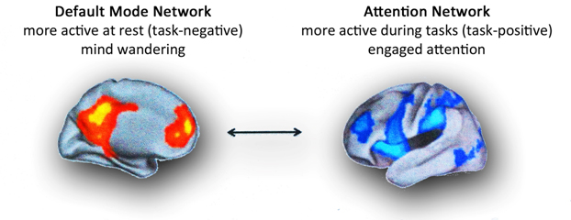

**Figure 3.** Network Activation

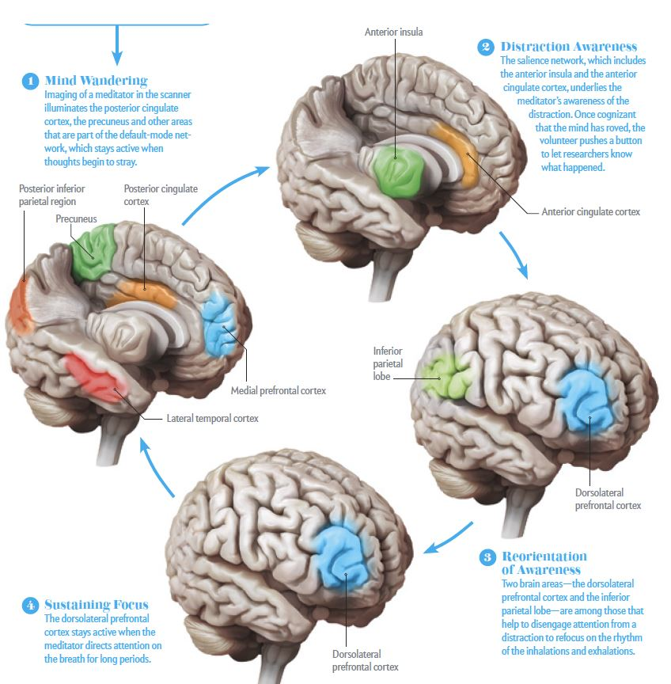

**Figure 4.** Task Positive Network vs Default Mode Network during Mindfulness meditation

**Intervention: Noting Practice**

**Estimated Duration**: 15 to 20 minutes

**Materials Needed:**

* Mindfulness Practice Checklist
* Files from “***Mindfulness Practice Audio”*** folder:
  + ***Baseline.WAV***
  + ***Story 1***
  + ***Story 2***
  + ***Story 3***

**Instructions:**

**Part I: Training Practice**

Use the Mindfulness Practice Checklist to take note of participant’s progress.

Introduce ***Practice Mindfulness Training***

*In a moment, we’ll review a technique that you will use later. But first, let’s do a brief memory exercise. You’ll hear a story and let’s see how many details you can remember from it.*

Open “***Mindfulness Practice Audio”***. Play ‘***Baseline.WAV.’***

*Please repeat the short story back to me with as many details as you can remember.*

In Mindfulness Practice Checklist: Enter “1” next to the detail that was remembered.

**Part II: Noticing/Noting Practice**

*Okay, great job. Now, we’re going to explore something called a “Noting Practice,” to help focus our awareness. We can find lots of examples of this awareness in our daily lives. For instance, right now, in this very moment you can* hear *the sound of my voice. Just hearing the sound of my voice doesn’t require any special effort from you, it just happens effortlessly. When you start* listening, *however, or try to* understand *what I’m saying, effort is required. You have to process the sounds, make them into words, and make sense of the words as communicating meaning. All those extra steps beyond hearing the sounds require effort and energy, even if they are relatively small amounts of each. Does that make sense? Can you think of any other examples of the more effortless type of attention or awareness?*

Engage in a brief discussion to elicit one or more additional examples from the participant that demonstrate comprehension.

*Today we’re going to expand this idea and try to help you stay in or maintain the type of attention or awareness that happens in the examples you just gave me. To do so, we’re going to practice “Noting,” as I mentioned a minute ago. It’s pretty straightforward once you get the hang of it, even though it might sound a little unusual compared to what we typically think about.*

*So, to do this Noting Practice, you just “note,” or pay attention to, the sensation or feeling that you recognize moment-to-moment. In class when you take notes, you’re jotting down the important thing that your teacher says. Here, you’ll mentally jot down the sensations or feelings that you are most aware of at any given second. The goal is to try to make yourself aware of your senses like seeing, feeling, hearing, tasting, smelling, and, for this Noting Practice,* thinking*.*

*An example will help to make this clearer. Let’s take right now, if I were doing a Noting Practice, I might note* seeing*, because I’m reading this, then I might note* feeling *because I can feel the paper in my hands, then I notice that I am* hearing *a sound in the hallway, then I might note* feeling *again because I can feel some tension in my shoulders, then I start thinking about the fact that my shoulders are tense, so I note that:* thinking*. Altogether then, a sequence could go something like, “seeing, feeling, hearing, feeling, thinking, thinking, feeling” and so on.*

*Whatever sense you are most aware of, note it. Unlike what I just did to demonstrate, you don’t need to describe specifically what you’re experiencing, just note which of your senses you are using and, once you have identified that sense, note the next one and move on.*

*This next part is important: you don’t need to try to change what you’re doing or make any sort of judgment about what you’re feeling or thinking or anything else. Once you’ve taken note of a sensation, let it go and note the next one. Just let yourself keep going from one moment and one sensory experience to the next. As you get started, it can be helpful to try set a pace of one “note” every few seconds or so, but feel free to do whatever is most comfortable for you!*

*Does all of this make sense? Do you have any questions?*

Assess comprehension and answer any questions.

*Okay, great. Now, before I ask you to give it a shot, let me show again how it might go for me; this time, I won’t add the descriptions.*

Demonstrate **Noting Practice** out loud (~15 seconds, noting approximately once every few seconds).

*Did you notice that I sometimes got stuck on* thinking *for a couple “notes” in a row? Although that’s fine, we want to make sure that we’re sticking with our sensations as much as possible. So, here’s a tip: when I get stuck in too many loops of* thinking, *I use an* **anchor** *to help switch my attention from inside my head to outside of it.*

*What’s an anchor? I’ll tell you! It’s something that I can – and you can – reliably notice and tune into to reset your noting practice. I use my right big toe a lot of times. That means whenever I notice that I’ve noted* thinking *a few times in a row, I remind myself to pay attention to how my big toe is* feeling*. Right now, my big toe feels the knit fabric of my sock, the side of my shoe around that it rubs against; I can feel the warmth of my big toe nestled inside my shoe, and the sole of my shoe that it’s pressing against just slightly as it rests on the floor.*

*All of these quick, little observations about my big toe give me an easy way to get back to more physical* sensations *and out of a sequence of* thinking*. Make sense?*

*So, now it’s your turn to pick your own anchor. You could choose a body part, like your elbow resting on the chair arm, the knee your opposite leg is resting on, the base of your head touching the headrest of the chair – anything that will shift your attention away from a series of* thoughts *and back to the here and now of* sensing*. While you’re practicing here with me, keep in mind that you’ll be asked to do this same noting exercise in the scanner later. You could choose your head resting on the cushion, the feeling of your shoulders on the bed, the texture of the squeeze ball in your hand…*

*What would you like to use for now?*

If the participant choses their breath as an anchor, encourage them to select an alternative. Explain that, since this is the same exercise, they’ll be asked to do in the scanner, they should opt for an anchor that is not based on movement of the body (as it be harder to keep still in the scanner).

In Mindfulness Practice Checklist: Write down participant’s **anchor** choice.

**Part III: Noting without External Distractors**

*Now you have all the pieces of the Noting Practice puzzle. Are you ready to try?*

*Remember, all you need to do is note any sensation (feeling, hearing, seeing, tasting, smelling, or that extra one, thinking) at the forefront of your attention for the next 10 seconds or so? You won’t have to do this every time, but just for the first time, I’d like you to note your sensation observations out loud. You also don’t need to tell me the description of what you’re noting, just the sensation.*

*Also, please don’t worry about doing it “right”. There is no wrong way! It’s also okay to not “get it” right away and it might be hard to get yourself out of* thinking *– that’s okay, too! In fact, just the act of practicing this exercise will help to engage that “attention network” we talked about a little bit earlier. There is no pressure to go quickly or do it perfectly. Just do the best you can. If your mind wanders or you get caught up or swept away by something, no problem. It is absolutely normal. When you become aware of that happening, remember you picked an anchor for that very reason! Return to your anchor and just start again by noting whatever sensation you notice first and strongest in that moment.*

*Okay?*

In Mindfulness Practice Checklist: Write down the participant’s verbalizations in short-form. Stop after the participant is able to check all boxes on the checklist for two times, or until three practices have been completed.

**Part IV: Noting *with* External Distractors**

*Great job! Now let’s practice again, this time with some background noise. The reason for this next practice set is that, in the scanner later and in the real world, I want you to be able to do this Noting regardless of what’s happening around you. For this sequence, you’ll hear a simple story playing while you do the same Noting practice you’ve been doing so far. As before, try to pay attention to your sensations despite the story playing at the same time. As you do this, you don’t have to force your attention away from the story – doing that might actually make this feel harder! Instead, just try to focus your attention on your senses.*

*I’ll say, “start,” when you should begin the Noting Practice and give you a few seconds to get that going before I start the story. When the story ends, you’ll hear me say, “stop.”*

*Does all of this make sense?*

Play “**Story 1**” in “***Mindfulness Practice Audio.”***

*Now, tell me every detail of the story that you heard and can remember.*

In Mindfulness Practice Checklist: Play Stories 2 through 4 until the participant is able to reduce the number of details provided (as indicated on the checklist) *two consecutive times*.

Review **Noting** experience.

**Part V: Putting Everything Together**

*So, what’s the point of all this? Well, do you remember the brain networks we talked about? This technique can be used to quiet streams of consciousness, including the types that contribute to or are part of the contents of ruminative or anxious thoughts and the activation of the* “default network”*. As we talked about, by reducing activity here, you may also quiet or learn to tune out negative thoughts and distressing feelings that go along with being stuck in worrying or rumination. If you practice regularly, this type of exercise will also make those kinds of thoughts, and the accompanying* “default network” *activity, more easily managed, less frequent, and less intense.*

**Scanner Instructions**

**Estimated Duration**: 10 minutes

**Materials Needed:**

* Feedback video files from “***Scanner Instructions***” folder:
  + ***Feedback.mov***
  + ***No_feedback.mov***
* Images from “***Scanner Instructions****”*folder:
  + ***fMRI Brain Scan***

**Instructions:**

Open “**Scanner Instructions**” folder and show participant “**fMRI Brain Scan.”**

*Let’s talk about how you’ll to take what we’ve practiced in here and use it while you’re in the scanner.*

*Fortunately, it’s simple because you’ll just be doing the same thing – noting your sensations and experiences in the here-and-now, except you’ll be doing that while you’re in the scanner instead of sitting here with me. You’ll also get “feedback” in the moment, based on the activation of those two distinct networks, the* “default network” *and the “*attention network*”.*

*This is what will happen: during the scan, you’ll see two circles and a white dot appear on the screen, similar to this one.*

Open “**Feedback.mov**” and point to the two circles and the white dot.

*There are two circles, one yellow on top, and one blue on the bottom. The white dot in the center represents the activity between the* “default network” *and the “*attention network*”.*

*When the scan session starts, you’ll first see a plus sign (+). It will be visible on the screen for 30 seconds, then the dot will start moving either up or down, toward one circle or the other. Whenever you see the plus sign, it is very important to just relax and don’t worry about engaging either network or doing the noting practice, since this is used as a baseline to compare the active part of the scan.*

Press play to start the “**Feedback.mov**” and point to the dot moving.

*So, during this scan, as you silently* note *your observations from moment to moment, activating the “*attention network*” and quieting the* “default network,” *the dot will start moving up, towards the yellow circle.*

*When you become distracted, with your mind wandering, you’ll see the dot move toward the blue circle, showing that your* “default network” *is more active than the “*attention network*.” This is bound to happen at some point, of course, and will be a reminder to silently return to your noting practice.*

*The goal of the feedback exercise in the scanner has two components: (1) To give you practice with the noting exercise that will be helpful to quiet your worrying or ruminating mind in real life and (2) To show you visually and in real-time how your brain is activated by different types of attention and awareness. We hope that by seeing this in real-time, based on your unique brain’s activation, learning how to control the dot’s movement will help you to become even better at turning off the “*default network*” and turning on your “*attention network*.”*

*I want you to remember through the exercise in the scanner that the visual feedback is to help you learn and see which network you are using. There is no reward or punishment for your performance and there is no doing this “right” or “wrong.” Rather, the circles are there to support your practice and to help ground you in feeling when you are using the “default” verses “attention” networks.*

*Does all of this make sense, too?*

Pause to answer any questions with the participant and ensure their comprehension.

*Before we practice once more in here, I have two more important notes. First, while in the scanner, try to just keep a soft gaze in the screen’s general direction. You don’t need to be overly focused on any of the objects on the screen. It is important, however, to remain as still as possible. Second, don't try to forcefully move the dot in any direction because, as you’ll see, doing so will actually activate the* “default network” *in the same way that other examples of being “caught up” trigger that network. Instead, simply practice noting the sensation you are most aware of moment-to-moment, then see if the dot goes up or down according to your experience.*

*Does that make sense?*

*Great, now let's practice.*

*On this screen, you’ll now see a simulation of the feedback you’ll receive during the scan, where the dot in the center moves while you are doing the noting practice. Of course, this does not represent your actual brain activity, but will give you an idea of what to expect.*

*Remember, you’re trying to move the white dot towards the yellow circle.*

*Ready?*

Rewind and press play again to start the “Feedback.mov” while the participant looks at the screen and does the noting practice. Explain that they might be able to note sensations like the feel of the surface they are lying on, the weight of their head on the pillow, the feeling of the blanket on their legs, etc.

*Finally, before we wrap up here, let’s practice once more.*

*This time, do your noting practice, the same way you learned and like you just did, but the dot will not move. You’ll hear sounds similar to those you will hear while you’re in the scanner. Just practice your* noting *skills and do your best as you have every other time.*

Open the “**No_feedback.mov**” while the participant looks at the screen and does the noting practice.

*Does this make sense?*

*Do you have any questions?*

*Great, let's get ready for the scan!*

**Appendix**

Story Text and Details

Baseline: Next Saturday is Mark’s birthday. Mark’s friends are going to hold a secret party for him. Tim is one of Mark’s best friends and loves to prank other people. Although everyone usually eats a sweet and well-decorated cake on their birthday, Tim is going to make one that is salty. He can’t wait to have Mark try the cake and laugh at his response.

1. Cathy is going on a field trip to a dairy farm. When Cathy gets to the farm, the farmer shows her how he makes fresh milk and creamy cheese. At the end of the day, the farmer said everyone can bring something home as a present for their parents. Cathy's mom and dad love pizza and Cathy's favorite food is macaroni and cheese. She knows exactly what to bring.
2. Alex the bear lives on the mountain. One sunny day, Alex was out looking for food. He saw a beehive on a tall tree. Alex climbed up and stuck his paw inside the beehive. He took his paw out and ate a lot of honey! Alex wanted to take a break, so he went to sit down in the shade under a big tree. Alex closed his eyes.
3. Zoey is going on vacation with her family by the ocean. She is so excited! She packed her favorite pair of sunglasses and her favorite bathing suit. They drive to the coast. But they see a lot of clouds in the sky and everyone’s hair is blowing in the strong wind. Soon rain starts pouring. Zoey is a little sad.
4. Grandpa owns a garden. He works there all year round. In March, he uses the shovel to dig holes in the soil and plants the potato seeds. From March to October, Grandpa waters and fertilizes the plants. In October, Grandpa carefully digs out the potatoes. In the winter, Grandpa takes a break.